LAB ASSIGNMENTS

HDFS:

1.Create a directory with your name under/user/<yourname>/hdfs directory in HDFS

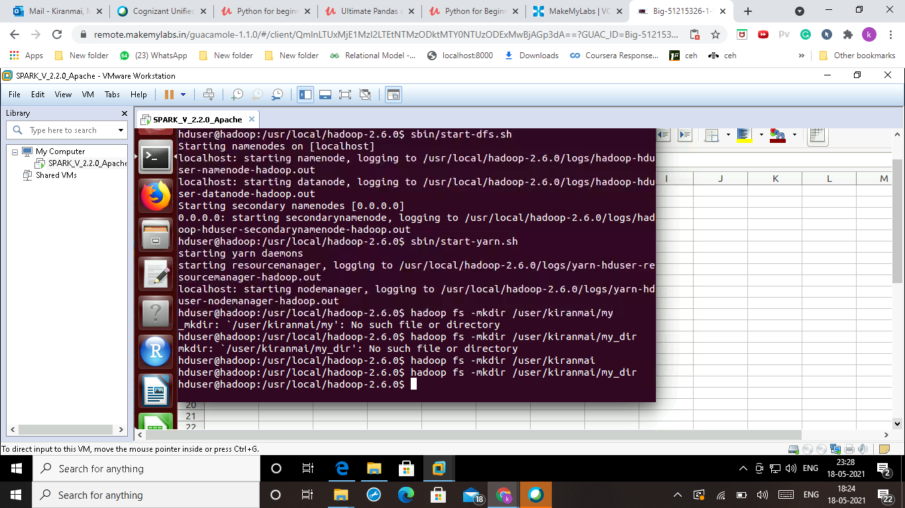

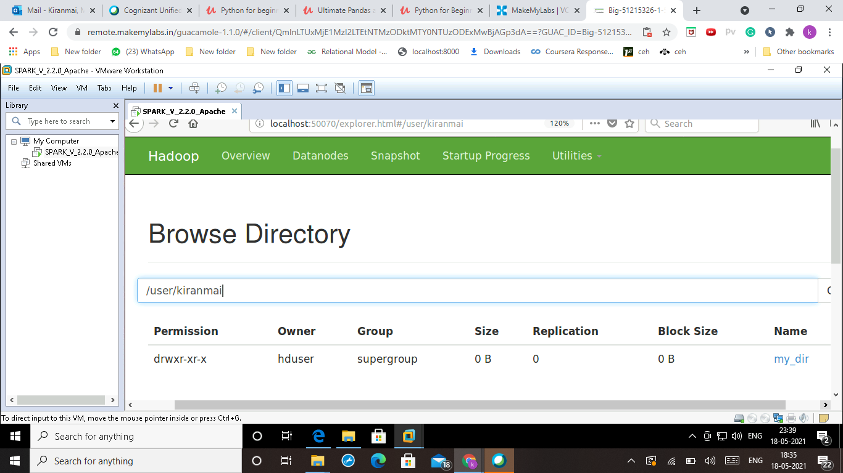

2.Create sample file on you local machine and upload that file in your directory in HDFS

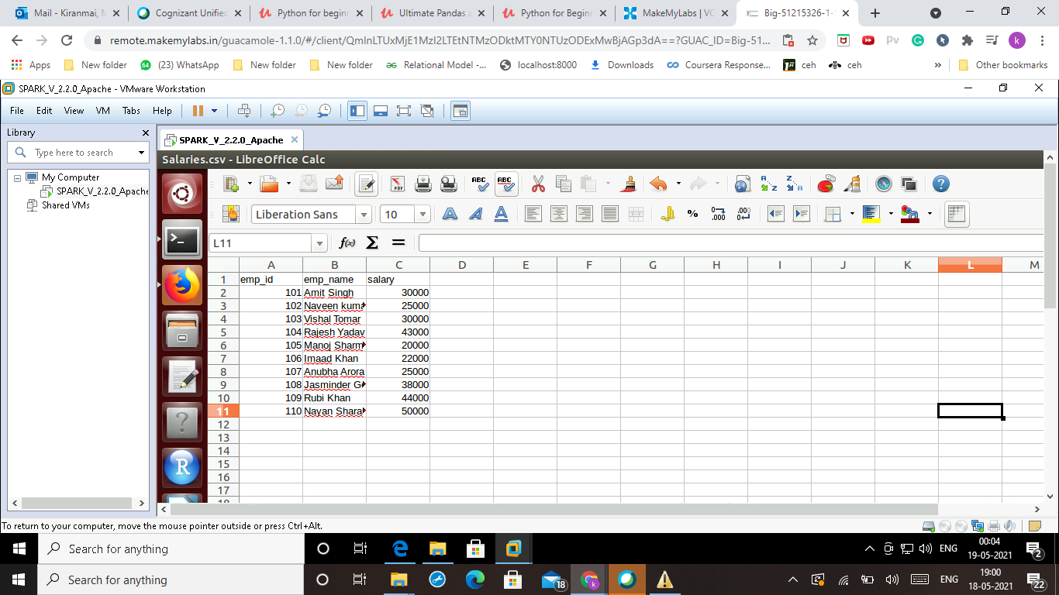

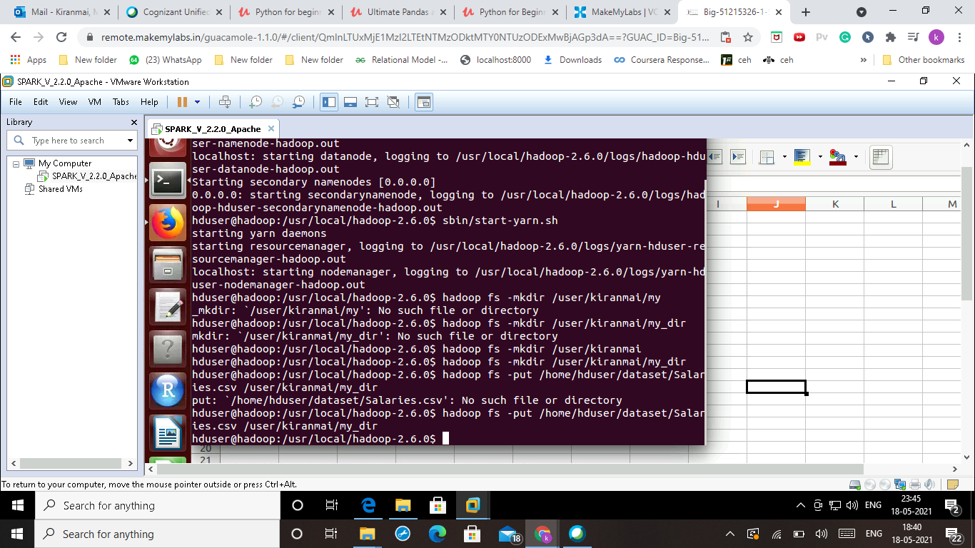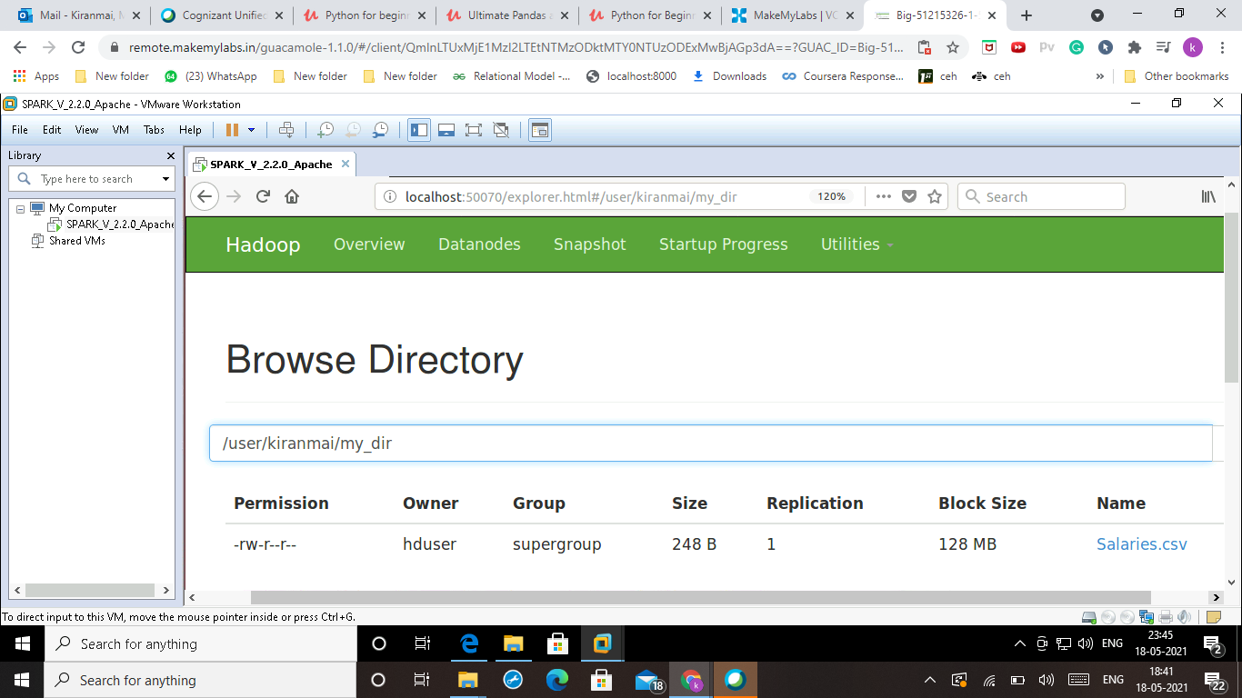

1. Execute HDFS report and find out block names in which your stored on Hdfs

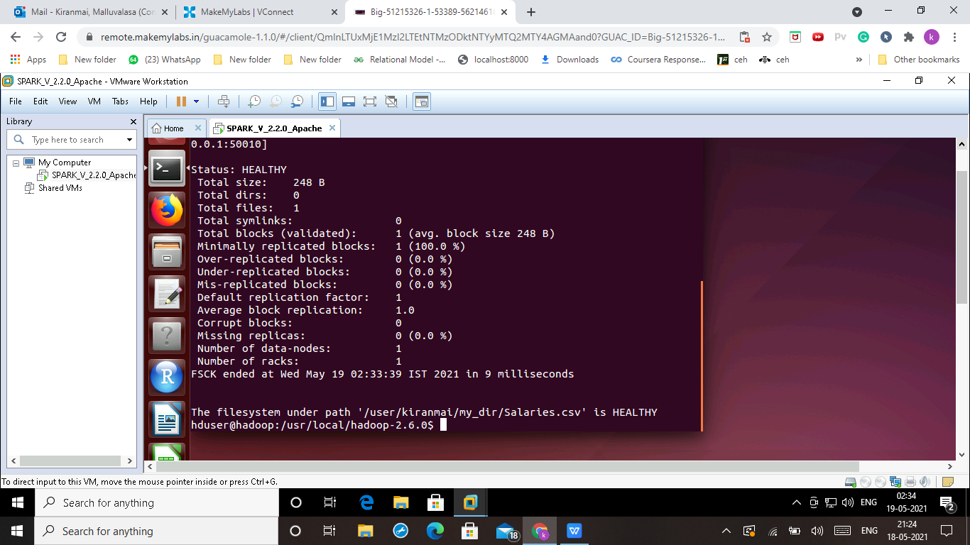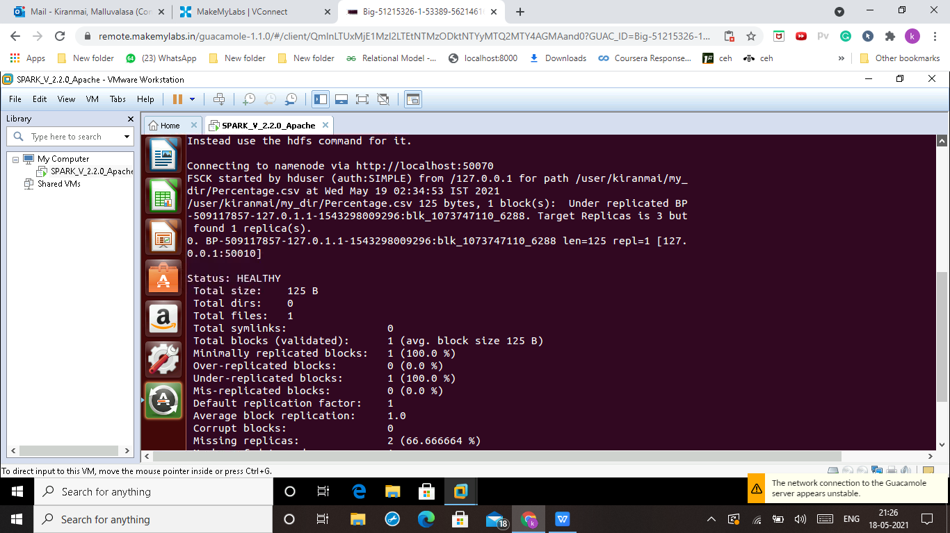

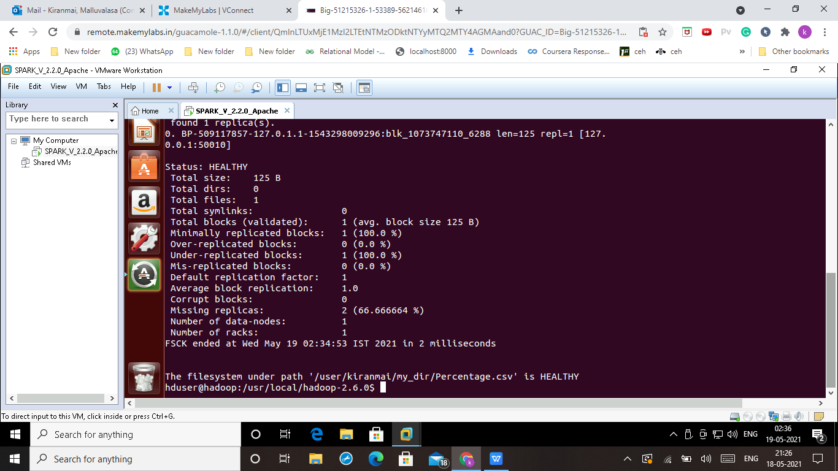

1. Create a new files on your local machine and upload it with replication factor 3 in your HDFS directory

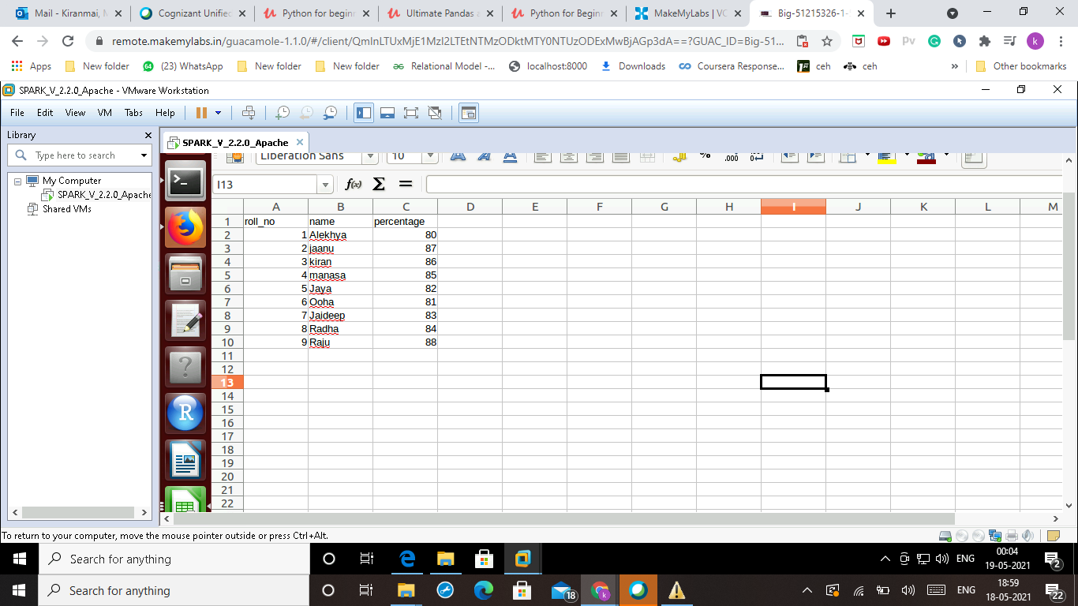

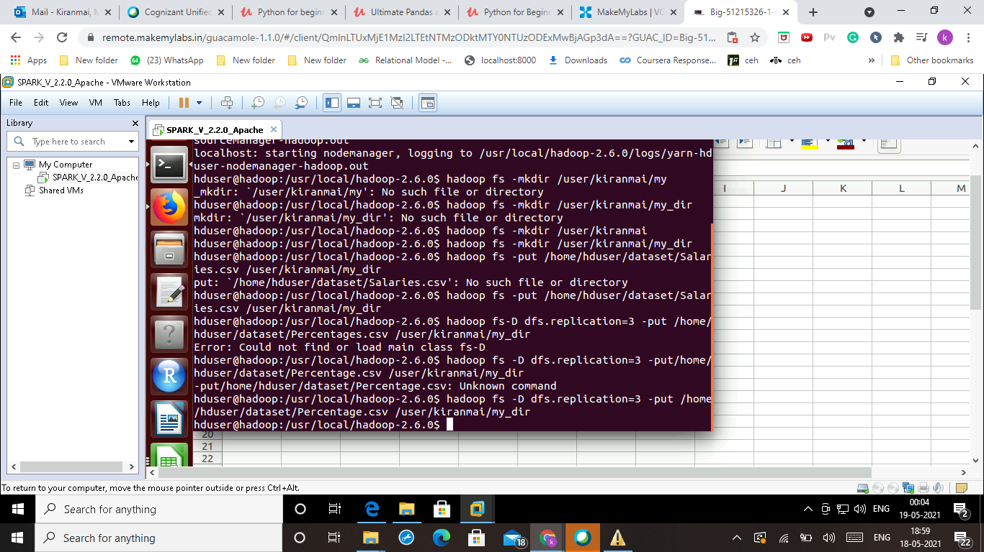

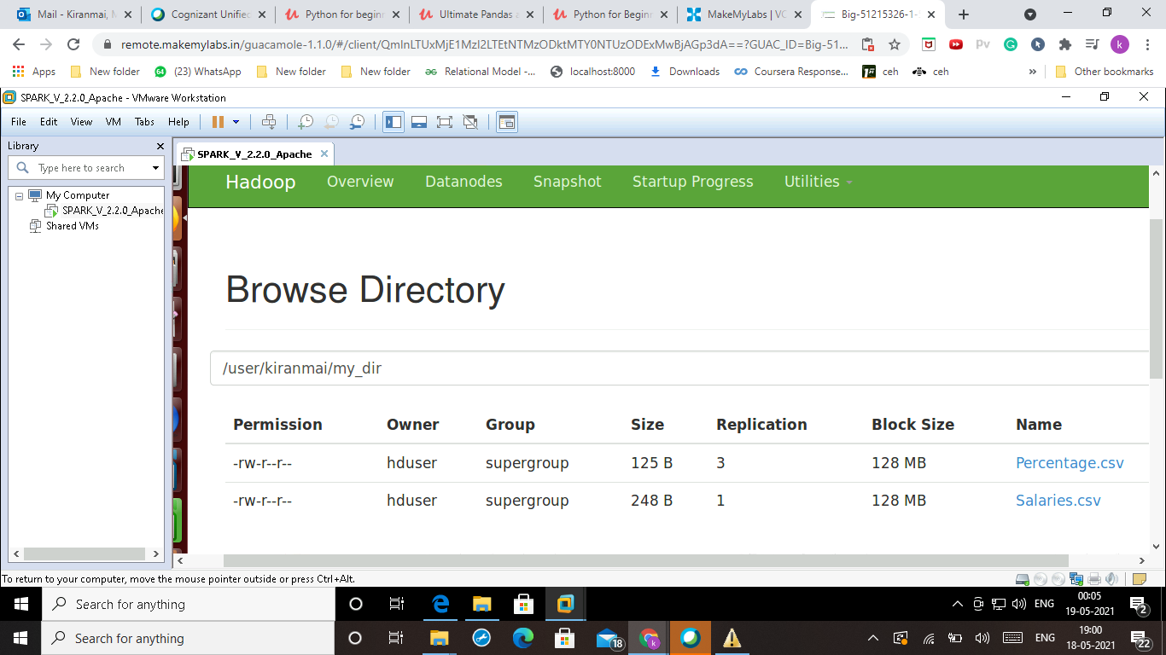

1. Download your both files from your directory on HDFS to your local machine

hadoop fs -get /user/kiranmai/my_dir/Salaries.csv /home/hduser/dataset/kiranmai

hadoop fs -get /user/kiranmai/my_dir/Percentages.csv /home/hduser/dataset/kiranmai

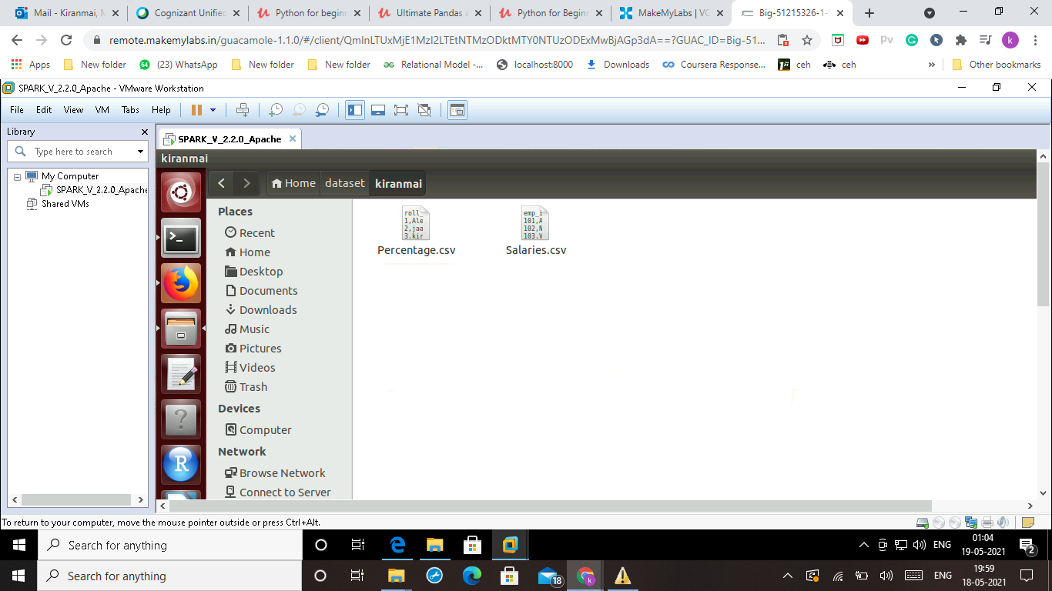

6.Display content of your file from your directory on HDFS to your local machine

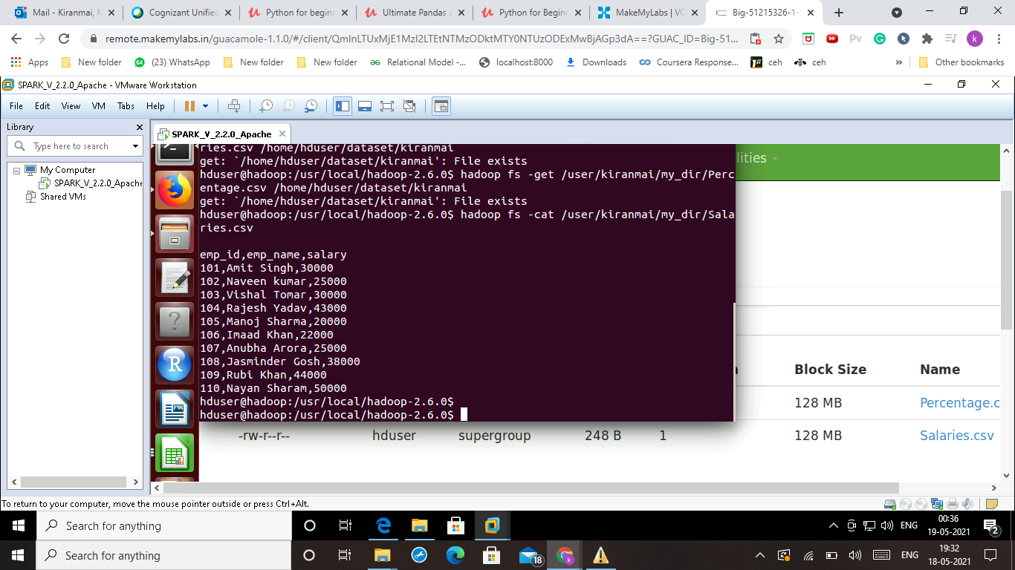

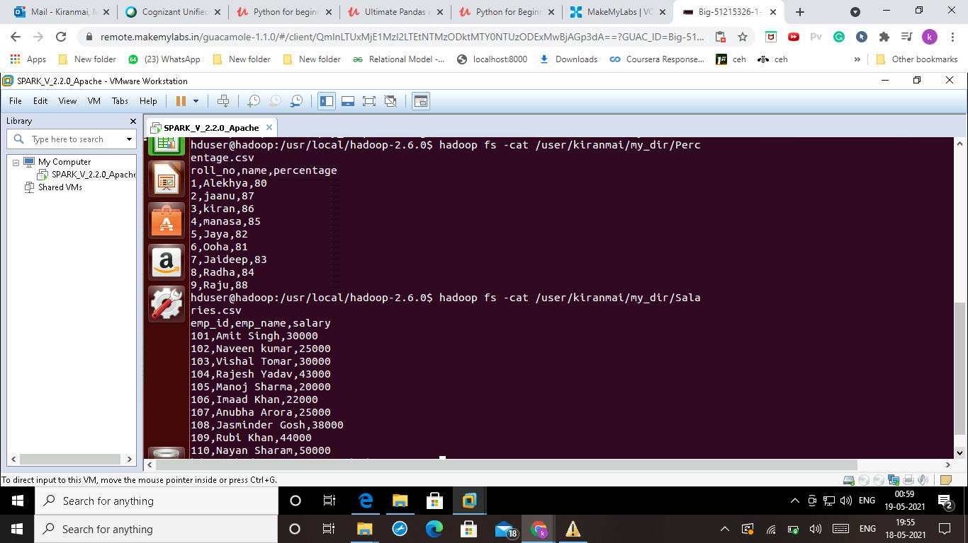

7.Create directory names “sqoop” under your directoty in HDFS

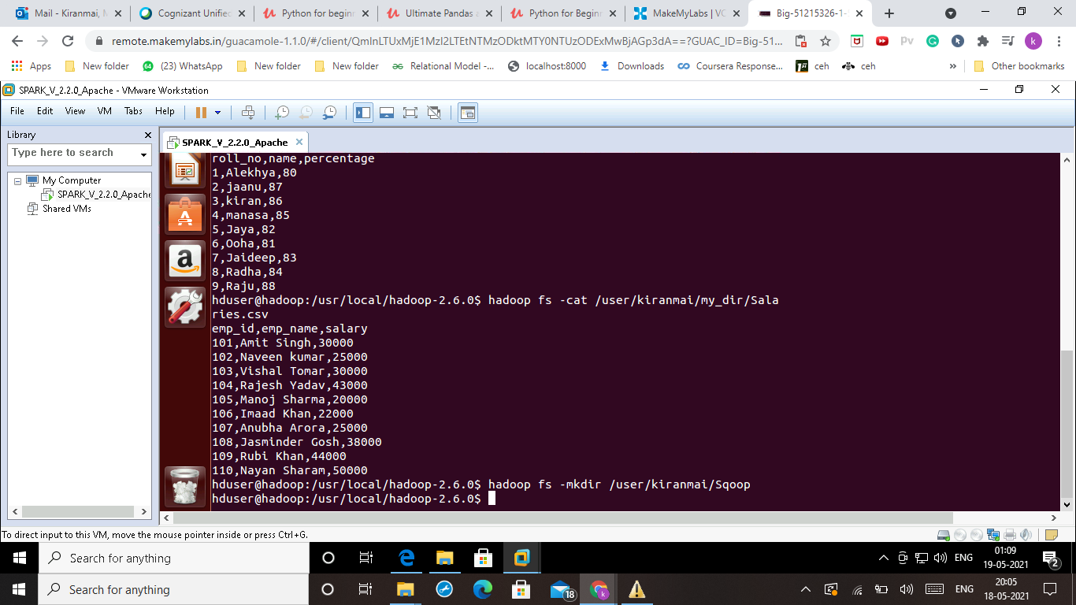

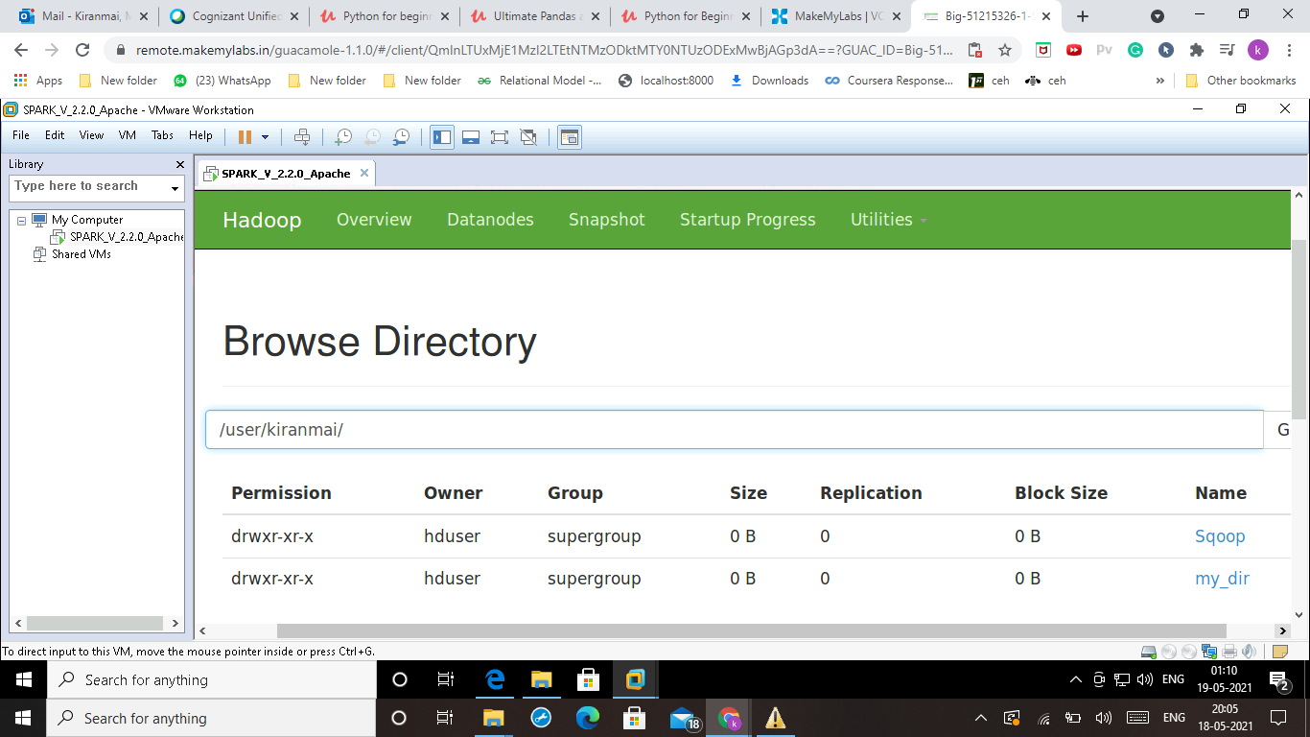

SQOOP:

1. Under sqoop directory on HDFS in your folder, create a new directories called “simple-import” and ”all-tables” and “incr-data”

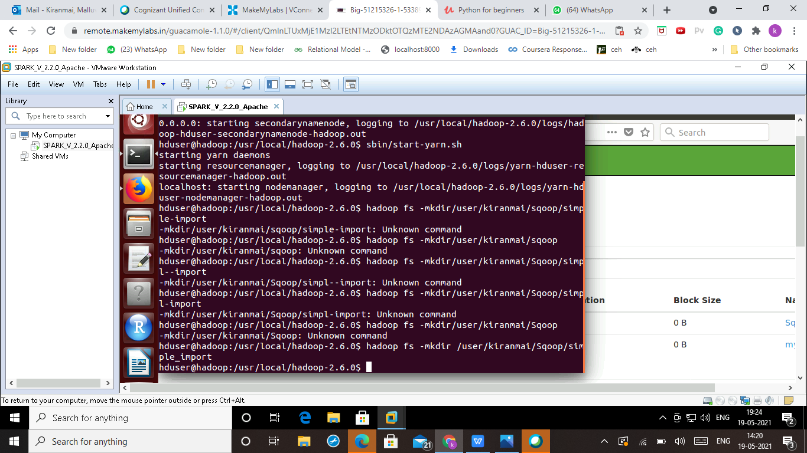

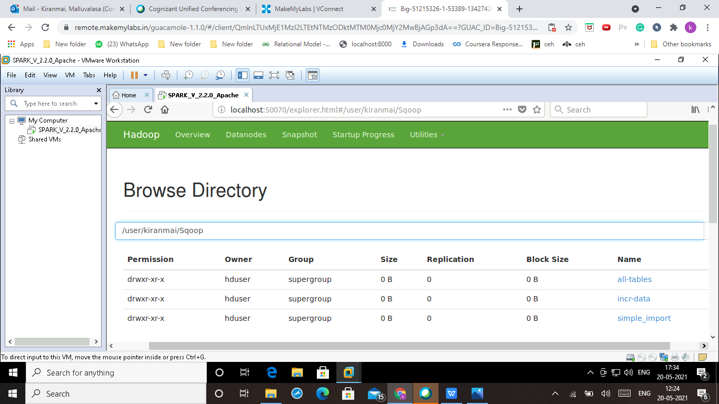

1. Connect to mysql installed on your local machine and create a database called “retail_db”. Choose retail_db in mysql and execute all commands in “retail_db.sql” file to create tables with data.

🡪Commands:-

mysql -u root -p

password: root

mysql> create database retail_db;

mysql> use retail_db;

mysql> CREATE TABLE categories (

category_id int(11) NOT NULL AUTO_INCREMENT,

category_department_id int(11) NOT NULL,

category_name varchar(45) NOT NULL,

PRIMARY KEY (category_id)

);

mysql> insert into categories values ((1, 2, ‘Football’),

(2, 2, ‘Soccer’), (3, 2, ‘Baseball’), (4, 2, ‘Basketball’),

(5, 2, ‘Lacrosse’), ),(6,2,'Tennis & Racquet'),(7,2,'Hockey'),

(8,2,'More Sports'),(9,3,'Cardio Equipment'),(10,3,'Strength Training');

mysql> CREATE TABLE customers(

customer_id int(11) NOT NULL AUTO_INCREMENT,

customer_fname varchar(45) NOT NULL,

customer_lname varchar(45) NOT NULL,

customer_email varchar(45) NOT NULL,

customer_password varchar(45) NOT NULL,

customer_street varchar(255) NOT NULL,

customer_city varchar(45) NOT NULL,

customer_state varchar(45) NOT NULL,

customer_zipcode varchar(45) NOT NULL,

PRIMARY KEY (customer_id)

);

mysql> INSERT INTO customers VALUES

(1,'Richard','Hernandez','XXXXXXXXX','XXXXXXXXX','6303 Heather Plaza','Brownsville','TX','78521'),(2,'Mary','Barrett','XXXXXXXXX','XXXXXXXXX','9526 Noble Embers Ridge','Littleton','CO','80126'),(3,'Ann','Smith','XXXXXXXXX','XXXXXXXXX','3422 Blue Pioneer Bend','Caguas','PR','00725'),(4,'Mary','Jones','XXXXXXXXX','XXXXXXXXX','8324 Little Common','San Marcos','CA','92069'),(5,'Robert','Hudson','XXXXXXXXX','XXXXXXXXX','10 Crystal River Mall ','Caguas','PR','00725'),(6,'Mary','Smith','XXXXXXXXX','XXXXXXXXX','3151 Sleepy Quail Promenade','Passaic','NJ','07055'),(7,'Melissa','Wilcox','XXXXXXXXX','XXXXXXXXX','9453 High Concession','Caguas','PR','00725'),(8,'Megan','Smith','XXXXXXXXX','XXXXXXXXX','3047 Foggy Forest Plaza','Lawrence','MA','01841'),(9,'Mary','Perez','XXXXXXXXX','XXXXXXXXX','3616 Quaking Street','Caguas','PR','00725'),(10,'Melissa','Smith','XXXXXXXXX','XXXXXXXXX','8598 Harvest Beacon Plaza','Stafford','VA','22554');

mysql> CREATE TABLE departments (

department_id int(11) NOT NULL AUTO_INCREMENT,

department_name varchar(45) NOT NULL,

PRIMARY KEY (department_id)

);

mysql> INSERT INTO departments VALUES (2,'Fitness'),(3,'Footwear'),(4,'Apparel'),(5,'Golf'),(6,'Outdoors'),(7,'Fan Shop');

mysql> CREATE TABLE order_items(

order_item_id int(11) NOT NULL AUTO_INCREMENT,

order_item_order_id int(11) NOT NULL,

order_item_product_id int(11) NOT NULL,

order_item_quantity tinyint(4) NOT NULL,

order_item_subtotal float NOT NULL,

order_item_product_price float NOT NULL,

PRIMARY KEY (order_item_id)

);

mysql> INSERT INTO order_items VALUES (1,1,957,1,299.98,299.98),(2,2,1073,1,199.99,199.99),(3,2,502,5,250,50),(4,2,403,1,129.99,129.99),(5,4,897,2,49.98,24.99),(6,4,365,5,299.95,59.99),(7,4,502,3,150,50),(8,4,1014,4,199.92,49.98),(9,5,957,1,299.98,299.98),(10,5,365,5,299.95,59.99);

mysql> CREATE TABLE orders (

order_id int(11) NOT NULL AUTO_INCREMENT,

order_date datetime NOT NULL,

order_customer_id int(11) NOT NULL,

order_status varchar(45) NOT NULL,

PRIMARY KEY (order_id)

);

mysql> INSERT INTO orders VALUES (1,'2013-07-25 00:00:00',11599,'CLOSED'),(2,'2013-07-25 00:00:00',256,'PENDING_PAYMENT'),(3,'2013-07-25 00:00:00',12111,'COMPLETE'),(4,'2013-07-25 00:00:00',8827,'CLOSED'),(5,'2013-07-25 00:00:00',11318,'COMPLETE'),(6,'2013-07-25 00:00:00',7130,'COMPLETE'),(7,'2013-07-25 00:00:00',4530,'COMPLETE'),(8,'2013-07-25 00:00:00',2911,'PROCESSING'),(9,'2013-07-25 00:00:00',5657,'PENDING_PAYMENT'),(10,'2013-07-25 00:00:00',5648,'PENDING_PAYMENT');

mysql> CREATE TABLE products (

product_id int(11) NOT NULL AUTO_INCREMENT,

product_category_id int(11) NOT NULL,

product_name varchar(45) NOT NULL,

product_description varchar(255) NOT NULL,

product_price float NOT NULL,

product_image varchar(255) NOT NULL,

PRIMARY KEY (product_id)

);

mysql> INSERT INTO products VALUES (1,2,'Quest Q64 10 FT. x 10 FT. Slant Leg Instant U','',59.98,'http://images.acmesports.sports/Quest+Q64+10+FT.+x+10+FT.+Slant+Leg+Instant+Up+Canopy'),(2,2,'Under Armour Men\'s Highlight MC Football Clea','',129.99,'http://images.acmesports.sports/Under+Armour+Men%27s+Highlight+MC+Football+Cleat'),(3,2,'Under Armour Men\'s Renegade D Mid Football Cl','',89.99,'http://images.acmesports.sports/Under+Armour+Men%27s+Renegade+D+Mid+Football+Cleat'),(4,2,'Under Armour Men\'s Renegade D Mid Football Cl','',89.99,'http://images.acmesports.sports/Under+Armour+Men%27s+Renegade+D+Mid+Football+Cleat'),(5,2,'Riddell Youth Revolution Speed Custom Footbal','',199.99,'http://images.acmesports.sports/Riddell+Youth+Revolution+Speed+Custom+Football+Helmet');

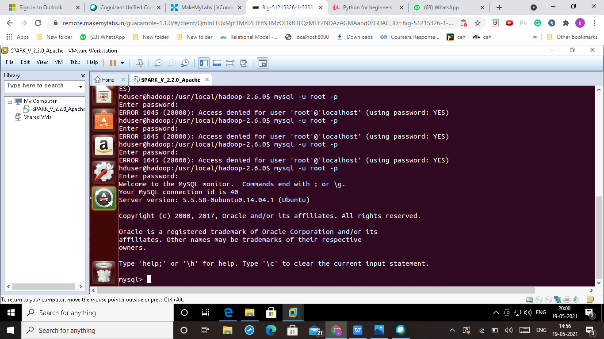

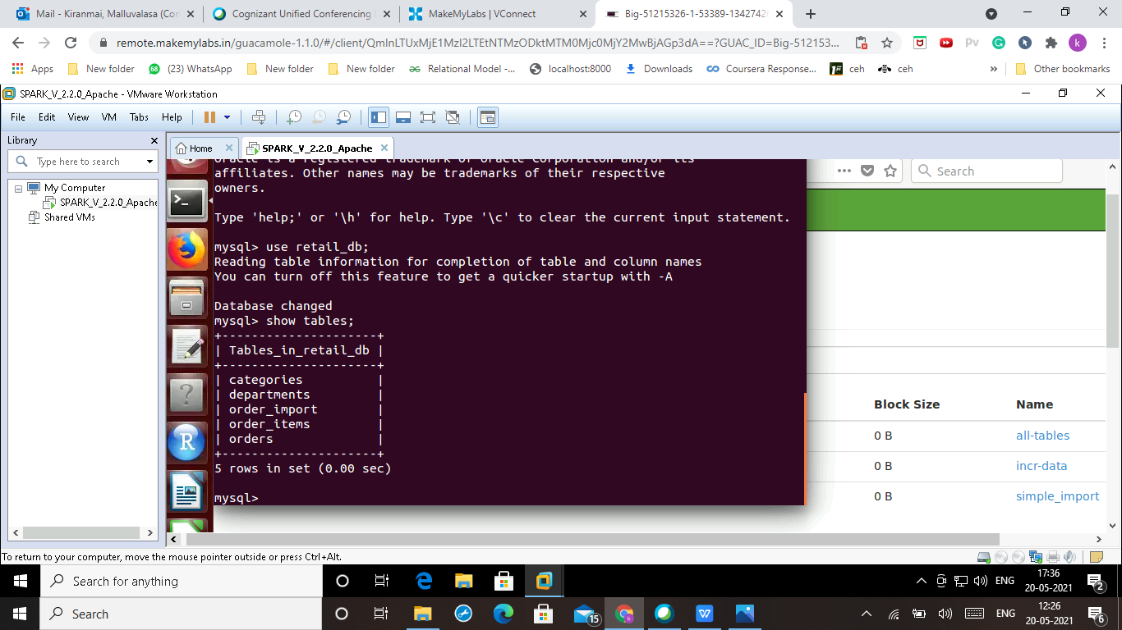

1. Using sqoop import orders table under “simple-import” directory on HDFS.

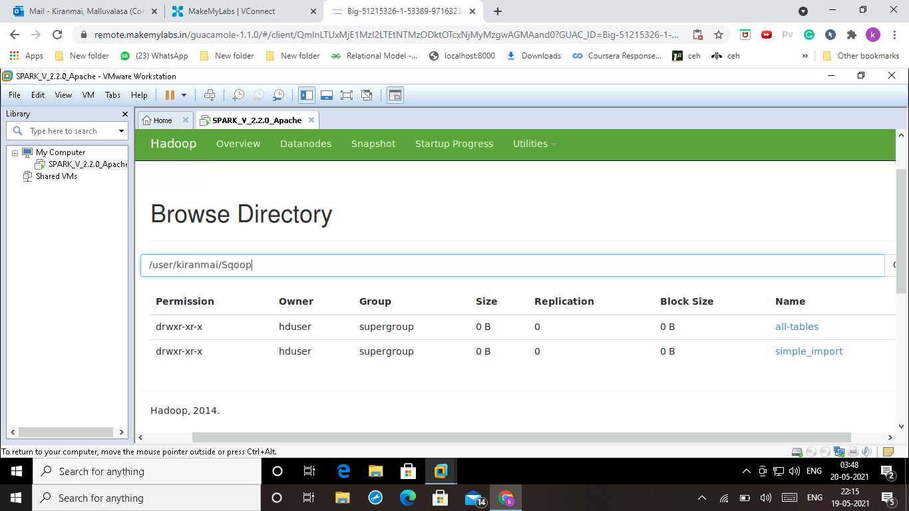

1. Connect to mysql and create a database with your name & create orders_import table using same DDL as orders table

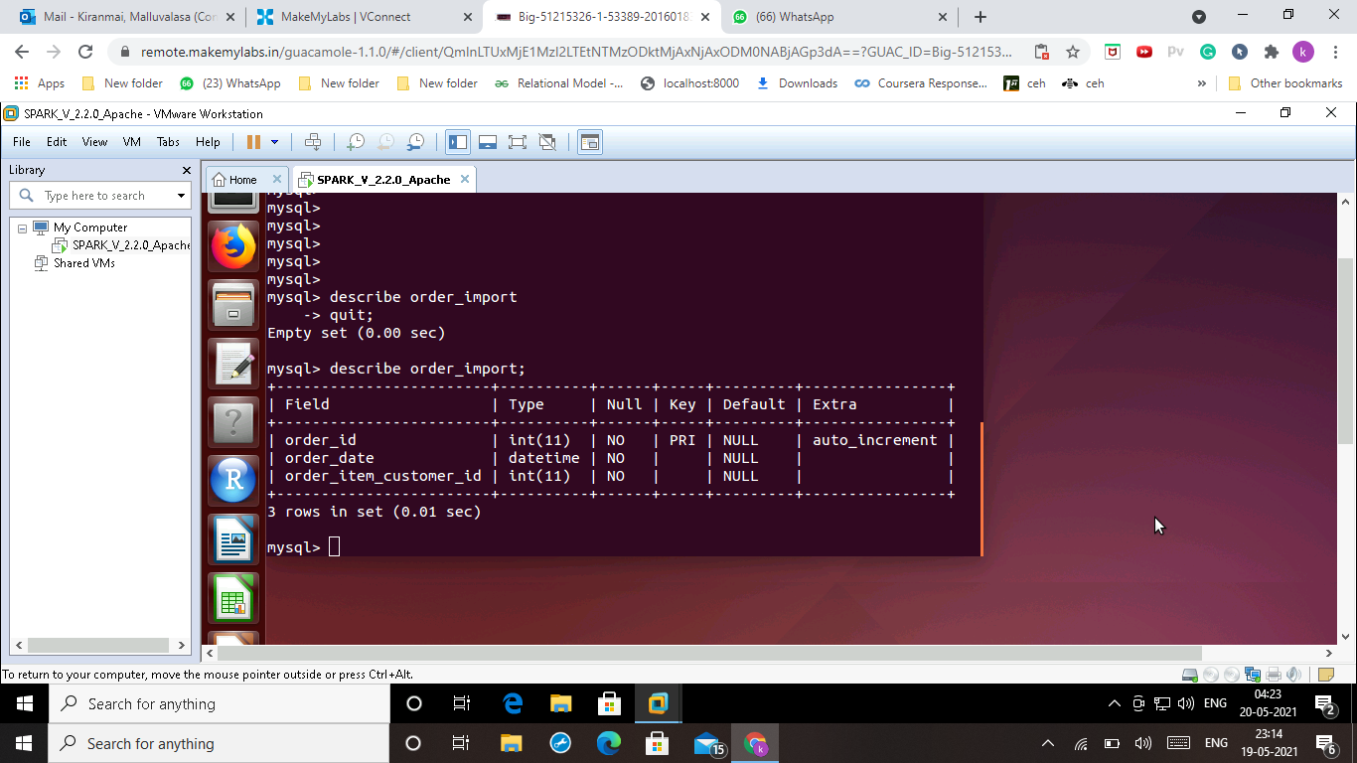

1. Using sqoop , export order data from HDFS under “simple-import” directory into your order_import tables in your database

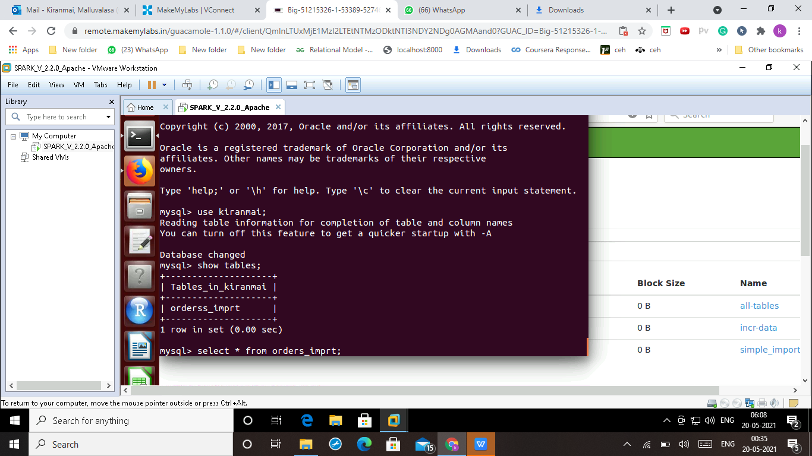

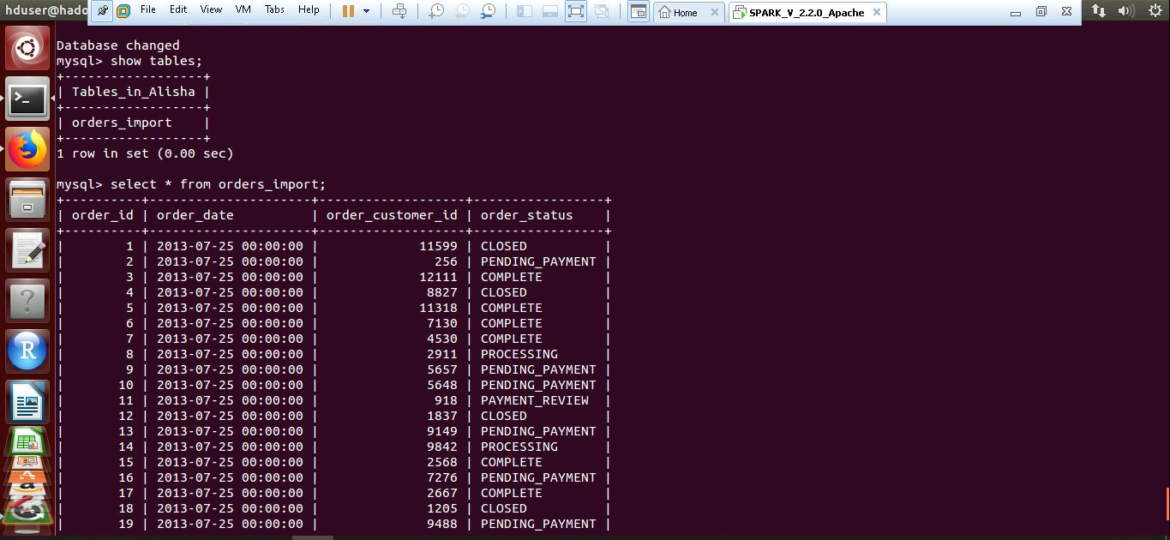

1. Using sqoop import-all-tables , dump retail_db in mysql in to “all-tables” directory. Verify data on HDFS

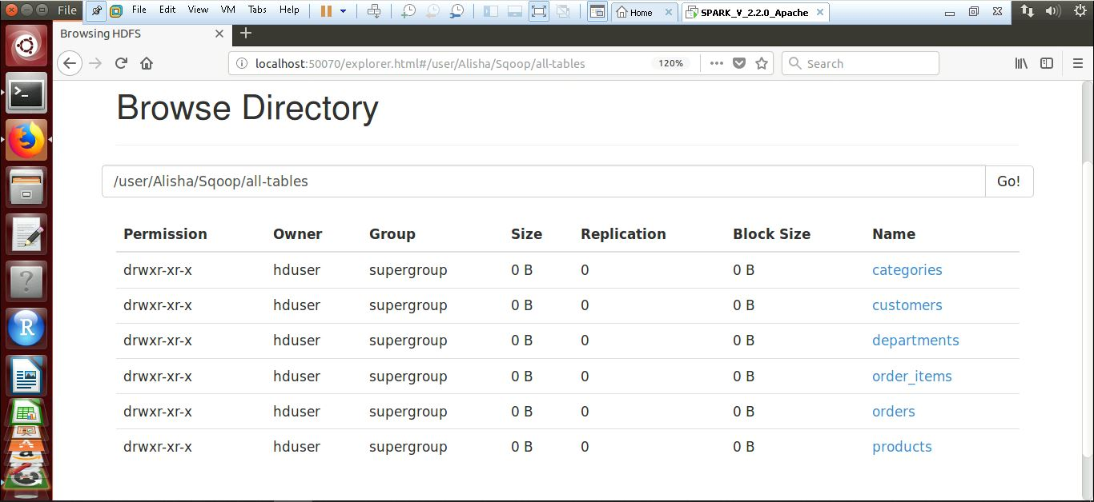

1. Create a sqoop job to import incremental data from orders table in to “incr-data” folder on HDFS

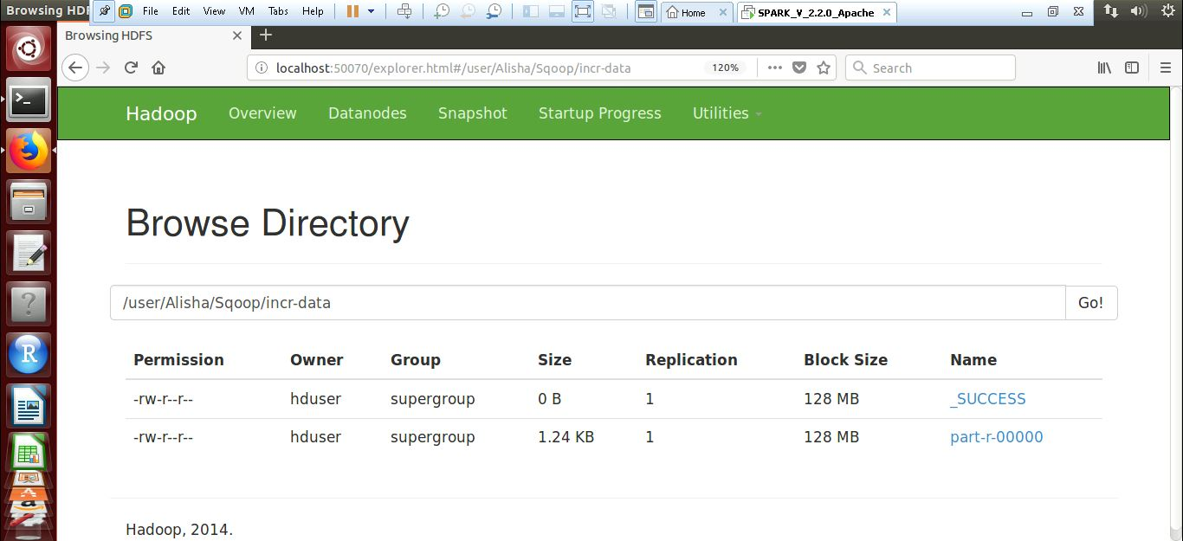

1. Execute sqoop job for 3 times to load incremental data. Make sure to add/update records in retail_db.orders table before running job.

mysql> insert into orders values(32, '2013-08-14', 51, 'CLOSED');

mysql>exit;

sqoop import --connect jdbc:mysql://localhost/retail_db --username root --password root --table orders --incremental lastmodified --check-column order_date --last-value "2013-07-25 00:00:00" --merge-key order_id --target-dir /user/kiranmai/Sqoop/incr-data

mysql> insert into orders values(33, '2013-09-14', 52, 'PROCESSING');

mysql>exit;

sqoop import --connect jdbc:mysql://localhost/retail_db --username root --password root --table orders --incremental lastmodified --check-column order_date --last-value "2013-08-14 00:00:00" --merge-key order_id --target-dir /user/kiranmai/Sqoop/incr-data

mysql> insert into orders values(34, '2013-10-14', 52, 'COMPLETED');

mysql>exit;

sqoop import --connect jdbc:mysql://localhost/retail_db --username root --password root --table orders --incremental lastmodified --check-column order_date --last-value "2013-09-14 00:00:00" --merge-key order_id --target-dir /user/kiranmai/Sqoop/incr-data